**Synopsis of Virtual Career Counselling System**

**Introduction to the Problem:**

In today’s competitive world the selection of right career path or academics is a big challenge. Educational and Career Guidance is not as simple task as it sounds. Nowadays Career counselors are available to help students in selecting streams in education or to provide guidance regarding career selection. Most of the counsellors charge high fees hence they are not accessible for each and every individual. We need a reliable, unbiased and effective system which can reduce this issue and will be able to neutralize the complexity of some problems. Our application “Virtual Career Counselling System” is an approach to resolve such problems and provide a better guidance to the students for building their academics and have a clear career perspective.

Choosing a career is not an easy task for students especially since the choice should be based on several criteria and at a relatively early age. This important decision not only affects the student but also the efficiency of school. Career development is a lifelong process. There are a number of factors that influence your career development, including your interests, abilities, values, personality, background and circumstances. Career guidance is a process that will help you to understand yourself in order to make career, educational and life decisions.

**Study of Existing System and its Limitations:**

**Existing system**

The Existing system of Counselling based on Traditional Approach, which is based on Person-to-Person Interaction (client-to-Counsellor). It is very time-consuming activity and costly as well. Finding a right counsellar is also a tough task. In India, most of time parents and elders make the choice of career for their wards without thinking much about their ward’s interest, academic performance, etc.

The existing systems has many drawbacks such as career counselors are not available always as per individual’s comfort. Guidance and counselling have been limited to few institutions therefor not all the students get counselling. Counselors charge a high amount of fees for guidance which is not affordable for everyone.

**Limitations:**

* There is no one stop solution for career guidance as the career guidance system in India is based upon subject matter experts (SMEs). These SMEs can only provide guidance in their own area of expertise.
* India being a very large country, has no centralized education policy. There are plenty of Universities, Colleges, Institutes which run their own curriculum and their own admission system. We do not have a central repository, where we can find a listing of all the entrance exams, admission processes etc. based upon our qualification.
* We do not have any system which can guide us for all the different education/career paths available for us based on our qualification and prior studies.
* There are a lot of resources on the Internet available providing different job openings, entrance exams, admission notifications. But all of those are on Self-Service mode. It is not like, the system itself suggests the best options available for you.

**Case Study:**

1. **Aglasem**

Aglasem.com is an online based education portal, which provides updates & information of all education related topics. It is a leading education guidance network and pioneer of massive online education communities. It provides study materials to students to study online & prepare for various competitive examinations through practicing multiple questions, sample papers & online mock test that will help them to prepare for their exams. It also engaged their students to go through various talent search programs that will help them to update themselves for various govt. jobs openings & all the study related relevant information at a single place. There is a one stop discussion forum to solve your queries related to exams, admissions, recruitment and everything to help you in your student life and career.

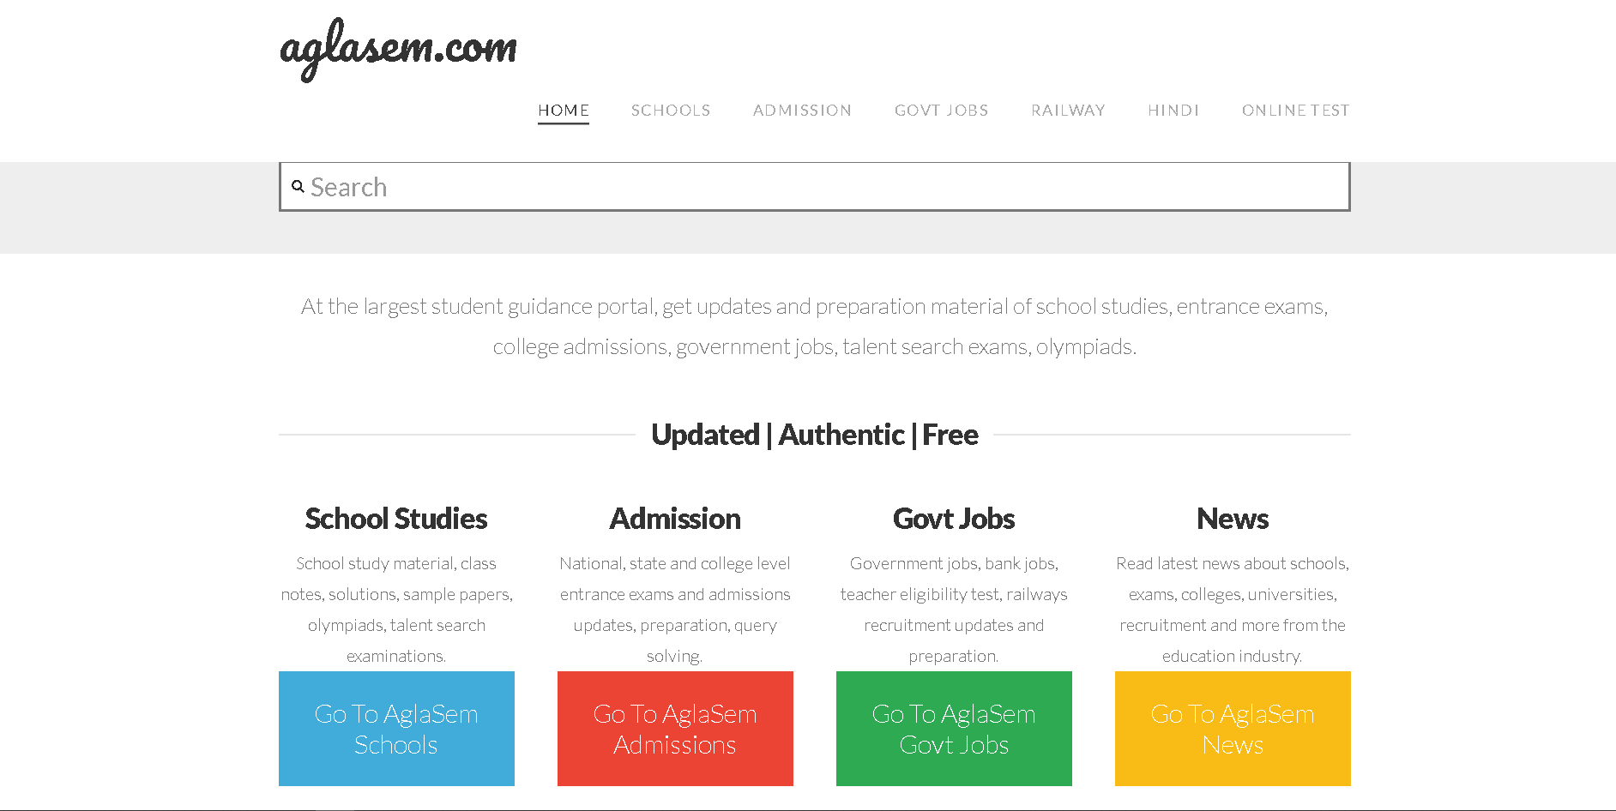

**It’s Limitations:-**

1. **Sarkariresults**

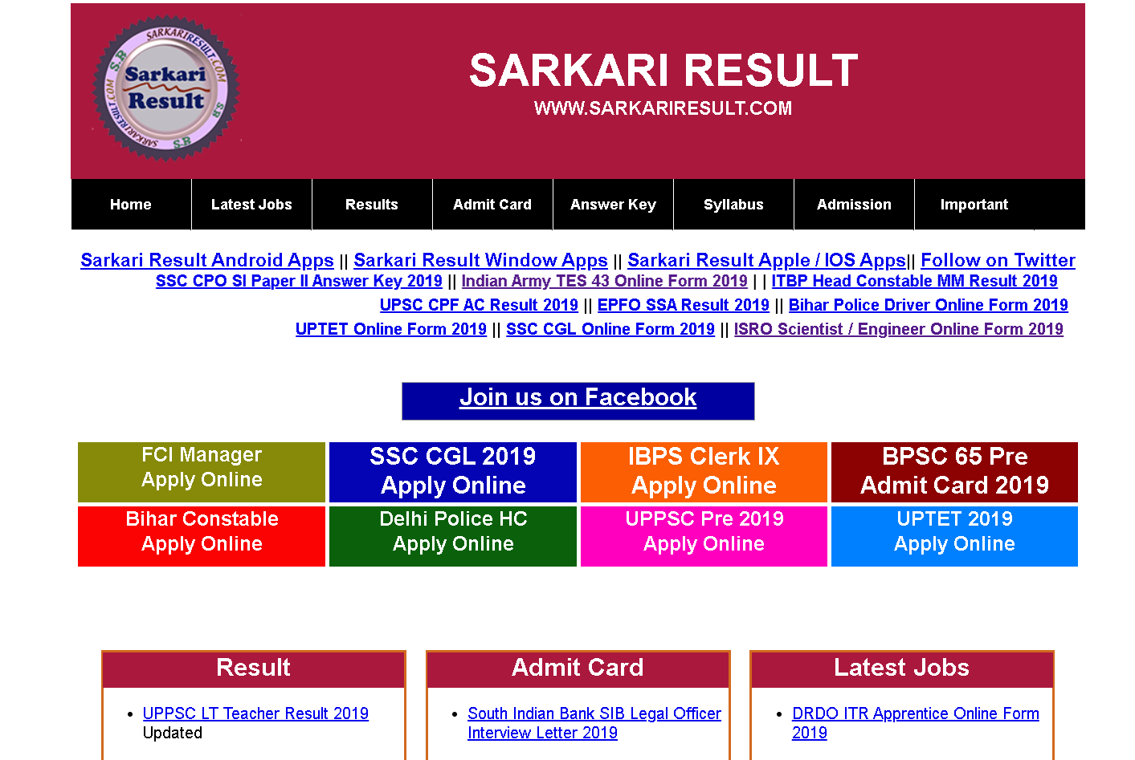sakariresult.com is a popular Job and Results portal in India. It provides information about sarkari exams, Jobs online, which is conducted by State Government of India & Central Government of India, Entrance exams, Board examinations, Bank exams and recruitments. All latest government jobs Results, Answer keys, Admit Cards, Rojgar Result and Top online form for various government departments. It also provides Exam Syllabus/ Pattern, Admission form, certificate verification, Up Rashan card. Board Result of all state of India is also available on this website. It also provides guidance about fill up the online application form, Application fee and form submission. All process from start to end is available for the job seekers in sarkariresult.com.

**It’s Limitations:**

**Proposed System:**

In the era of internet, students(youths) visit often to interact, shop, be entertained etc. Internet should also be used for something as productive and as important as interactive with an information system that helps them to choose the best career possible for them. The proposed system is a “Virtual Career Counselling System” which will address the concerned problems. This system will evaluate students on various aspects to suggest a career path. If this system is used in a constructive manner, a Virtual Career Counselling System can be more effective and accessible than a real-life counselor.

**Functional requirements:**